**TRAFFIC MANAGEMENT**

In this day & age, the conventional systems to manage urban mobility are proving incompetent. And there’s a growing need for an efficient traffic management system. Cities big and small are in dire need of technology-led digital solutions to manage & monitor traffic. They can help regulate heavy traffic, road blockages at signals & congested networks.

An Internet of Things (IoT)-enabled intelligent traffic management system can solve pertinent issues by leveraging technologies like wireless connectivity & intelligent sensors. Considered a cornerstone of a smart city, they help improve the comfort and safety of drivers, passengers & pedestrians.

With the pressing demand for advanced communication & network technologies, digitalization is the driving force that stimulates the implementation of smart traffic control using IoT capabilities.

It enables them to;

* Expand the capacity of city streets without having to build new roads.
* Optimize the traffic flow and keep the drivers safe. It would include cameras, sensors, and cellular technologies that automatically adjust traffic lights, expressway lanes, speed limits, and highway exit counters.
* Transmit accurate information about available parking spaces to citizens in real-time
* Collect data on congestion and improve traffic signaling to reduce blockages and optimize commute
* Locate incidents and report them to emergency rooms immediately with road sensors and video surveillance
* Employ real-time data feeds to ensure the streetlights turn dim or brighten up per the changing weather conditions and the onset of day and night

**Advantages of a Smart Traffic Management System**

Cleaner, greener, safer, and more accessible roads are a few benefits of implementing IoT and intelligent technology.

It helps with the following:

* Reducing traffic jams and accidents on the streets
* Ensuring immediate clearance for emergency vehicles
* Facilitating safer and shorter commute times
* Reducing congestion & energy consumption at intersections
* Offering significant productivity benefits with real-time monitoring of crucial infrastructures
* Reducing operating costs with efficient traffic management processes
* Ensuring compliance with the regulations for reducing the carbon footprint
* Saving billions of gallons of fuel wasted every year
* Accurate tracking & quick recovery of lost and stolen vehicles

**Functioning of Traffic Monitoring System Using IoT Capabilities**

This intelligent system comprises several components, including wireless sensors, RFID tags, and BLE beacons installed at the traffic signals to monitor the movement of vehicles. A real-time data analytics tool connects the Geographic Information System (GIS-enabled) digital roadmap with control rooms for real-time traffic monitoring.

The smart traffic management system captures the images of vehicles at the signals using the digital image processing technique. This data is then transferred to the control room via wireless sensors. The system also leverages BLE beacons or RFID tags to track the movement of vehicles and keep traffic congestion in control, track down stolen vehicles and even clear the road for emergency vehicles that are installed with RFID readers.

**Application of IoT in Traffic Management**

City governments can improve their operations & infrastructure by placing IoT sensors and tracking devices on roads and highways for recording, analyzing, and sharing data in real-time.

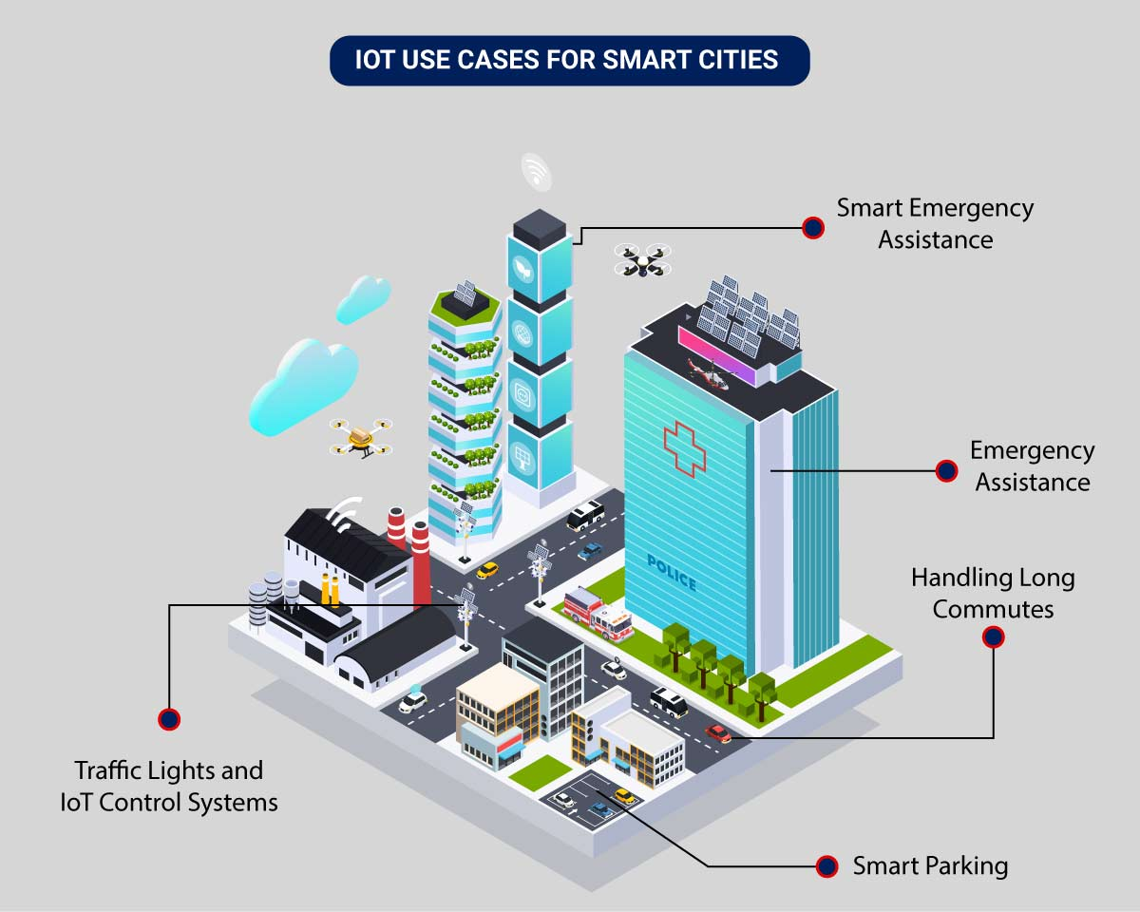

An intelligent traffic monitoring system using IoT capabilities has so many factors & use cases, including;

* **Traffic Lights and IoT Control Systems**: Smart traffic signals may look like a typical stoplight, yet they utilize an array of sensors to monitor real-time traffic. Usually, the goal is to help cars reduce the amount of time spent idle. And IoT technology enables the various signals to communicate with each other. This is while adapting to changing traffic conditions in real time. The outcome is less time spent in traffic jams and even reduced carbon emissions.
* **Parking Enabled through IoT**: Smart meters and mobile apps make on-street parking spaces easily accessible with instant notifications. Drivers receive alerts whenever a parking spot is available to reserve it instantly. The app gives easy directions to the parking spot with a convenient online payment option.
* **Emergency Assistance through IoT**: A traffic monitoring system using IoT technology enables emergency responders to speed up the care mechanism in case of accidents late at night or in isolated locations. The sensors on the road detect any accident, and the problem is immediately reported to the traffic management system. This request is passed on to relevant authorities to take corrective action. Emergency response personnel would include medical technicians, police officers, and fire departments for enhanced responsiveness and timely intervention.
* **Commute Assistance:**With every vehicle acting as an IoT sensor, a dedicated app can make suggestions, determine optimal routes & provide advance notice of accidents or traffic jams. Further, it can even suggest the best time to leave. It is all because of a robust algorithm that helps reduce driving time with intelligent traffic lights.

**Key Features of a Smart Traffic Management System**

The key features are listed below depending on the city’s size and the scope of the governmental policies. It can be integrated into an intelligent traffic management system. They include:

* **Traffic Jam Detection:**With cloud connectivity, sensors, and CCTV cameras tracking intersections 24×7, technicians can remotely monitor all the streets in real-time from the city’s traffic control room.
* **Connected Vehicles:**A smart traffic system using IoT technology can connect with roadside tracking devices to enable direct communication between intelligent vehicles & intersections.
* **Modular Control:**Real-time detection of congestion triggers dynamic adjustments in the systems meant for controlling traffic lights, express lanes, and entry alarms.
* **Emergency Navigation:**A system with edge data processing & programmatic alerting capabilities can alert response units (police, ambulance & tow trucks) in case of a car crash or collision. It reduces the crucial time an injured driver or passenger remains unattended.
* **Road Safety Analytics:** Systems with pattern detection capabilities can immediately flag high cruising speeds and reckless driver or inappropriate pedestrian behavior.
* **Digital Payments:** Commercial traffic management systems enable quick and convenient electronic transactions in real time while ensuring financial data safety.

# **Development of an IoT based real-time traffic monitoring system for city governance**

## Abstract

A significant amount of research work carried out on traffic management systems, but intelligent [traffic monitoring](https://www.sciencedirect.com/topics/earth-and-planetary-sciences/traffic-monitoring) is still an active research topic due to the emerging [technologies](https://www.sciencedirect.com/topics/earth-and-planetary-sciences/science-and-technology) such as the [Internet of Things](https://www.sciencedirect.com/topics/engineering/internet-of-things) (IoT) and Artificial Intelligence (AI). The integration of these technologies will facilitate the techniques for better decision making and achieve urban growth. However, the existing traffic prediction methods mostly dedicated to highway and urban traffic management, and limited studies focused on collector roads and closed campuses. Besides, reaching out to the public, and establishing active connections to assist them in decision-making is challenging when the users are not equipped with any smart devices. This research proposes an IoT based system model to collect, process, and store real-time traffic data for such a scenario. The objective is to provide real-time traffic updates on traffic congestion and unusual traffic incidents through [roadside](https://www.sciencedirect.com/topics/engineering/roadsides) message units and thereby improve mobility. These early-warning messages will help citizens to save their time, especially during peak hours. Also, the system broadcasts the traffic updates from the administrative authorities. A prototype is implemented to evaluate the feasibility of the model, and the results of the experiments show good accuracy in vehicle detection and a low relative error in road occupancy estimation. The study is part of the Omani-funded research project, investigating Real-Time Feedback for Adaptive Traffic Signals.

This research proposed an IoT based system model to collect, process, and store real-time traffic data. This research provided real-time traffic monitoring for traffic updates through roadside message units. The traffic authorities can also broadcast messages on [VIP](https://www.sciencedirect.com/topics/medicine-and-dentistry/vasoactive-intestinal-polypeptide) visits, medical emergencies, accidents, etc. to corresponding message units, which will assist the public in decision making and save their time on roads. The proposed system uses magnetic sensor nodes to collect real-time vehicle information. The real-time data is processed by WiFi-enabled microcontrollers and sends to an IoT platform for further actions. Whereas, the proposed system does not expect any smart equipped devices with the driver of the car or within the car such as sensors, [GPS](https://www.sciencedirect.com/topics/earth-and-planetary-sciences/global-positioning-system), WiFi, etc. and which makes this model unique. The proposed system is expected to be considered in any smart city initiatives such as a smart university campus or any closed smart premises. As a prototype was implemented to demonstrate the feasibility of the proposed model, the results of the prototype demonstration showed good accuracy in vehicle detection and a low relative error in road occupancy estimation. Thus, the proposed model can help citizens to save their time based on the early-warning messages displayed in the message unit, especially during peak hours. The traffic administration can send priority messages to the citizens; hence, the traffic congestion due to accidents or any such unusual incidents can be avoided.

